COMP3013 2025 Fall
Assignment 2
This assignment covers Lecture 1 – 7 and Lab 1 – 7.
Note: there is no requirement on ER diagram drawing. You are allowed to draw ER-diagrams using any tool. But you need to make sure that your drawing is clear enough. TAs have rights to remove marks if your graph unreadable. Please do not try to challenge us.
The makeup exam will be harder than this assignment.

Student are expected to submit two files.
- “COMP3013_25F_A2_XXX.sql”, where “XXX” is your student ID. This SQL file contains all the SQL queries for Q1. First line of the file should contain your name and ID as a comment. And question number for each question is also included as a comment. SQL comments are quoted by the sign /*…*/.
- “COMP3013_25F_A2_XXX.pdf”, for the ER diagram of Q2.
Submissions which do not following the guideline may not be marked.

Q1. The schema of a database is given as follows. Keys are underlined.
- student=(sID,sname,gender,age,gpa,pname)
// gender is either male or female.
- program=(pname,division)
// pgname is the program name
- course=(cID,cname,pname,credit)
// credit is an integer and $1≤$credit$≤3$.
- enroll=(sID,cID,grade)
//grade is one of A, B, C, D, or F.
Write a query for each following question. Please submit your answers of this question via iSpace Feedback. (8 marks for each)
- Find the course names that Goliath (student name) has taken.
Ans.
SELECT cname
FROM student NATURAL JOIN enroll NATURAL JOIN course
WHERE sname = 'Goliath'

- Display the number of students for each program.
Ans.
SELECT pname, COUNT(sID)
FROM student
GROUP BY pname

- Display the average GPA for among the students in each program by program name and average GPA.
Ans.
SELECT pname, AVERAGE(gpa)
FROM student
GROUP BY pname

- For each student, display the student ID, name, and the number of failed courses. If a student has not failed any course, the value should be 0.
Ans.
SELECT student.sID, sname, COUNT(cID)
FROM student LEFT OUTER JOIN enroll
ON (student.sID = enroll.sID AND grade='F')
GROUP BY student.sID;

- Define the tables from the logical schemas. ID numbers, ages, and credits for courses are integers. GPA is a real from 0.0 to 4.0. Other attributes are variable length character string. (10 marks for this question)
Ans.
CREATE TABLE program (
pname VARCHAR(100) PRIMARY KEY,
division VARCHAR(100)
);

CREATE TABLE student (
sID INT PRIMARY KEY,
sname VARCHAR(100) NOT NULL,
gender VARCHAR(10),
age INT,
gpa DECIMAL(3,1),
pname VARCHAR(100)
);

CREATE TABLE course (
cID VARCHAR(20) PRIMARY KEY,
cname VARCHAR(200) NOT NULL,
pname VARCHAR(100) NOT NULL,
credit INT
);

CREATE TABLE enroll (
sID BIGINT NOT NULL,
cID VARCHAR(20) NOT NULL,
grade CHAR(1),
PRIMARY KEY (sID, cID)
);

- Implement foreign keys for enroll, student, and course.
Ans.
ALTER TABLE student ADD
FOREIGN KEY (pname) REFERENCES program(pname);
ALTER TABLE course ADD
FOREIGN KEY (pname) REFERENCES program(pname);
ALTER TABLE enroll ADD
FOREIGN KEY (sID) REFERENCES student(sID);
ALTER TABLE enroll ADD
FOREIGN KEY (cID) REFERENCES course(cID);

- Student Goliath receives an A (grade) in the course COMP30131(course ID). Add this record to the system.
Ans.
INSERT INTO enroll (sID, cID, grade)
SELECT sID, 'COMP3013', 'A'
FROM student
WHERE sname = 'Goliath'
;

- Student Dave of ID 1840007211 has been dismissed from the college. Remove his information from the database.
Ans.
DELETE FROM enroll WHERE sID = 1840007211;
DELETE FROM student WHERE sID = 1840007211;

Q2. Modify the given ER-model for Q2 in Assignment 1 to further model the following constraints. (18 marks)
- Every degree is offered by a university.
- Some degrees can be offered by multiple universities.
- Every university offers some degrees.
- Some alumni continue their studies in some universities for some degrees.
- Every degree is obtained by some alumni.
- Some alumni are not working.
- One alumnus works in at most one company.
- Every company employs some alumni.
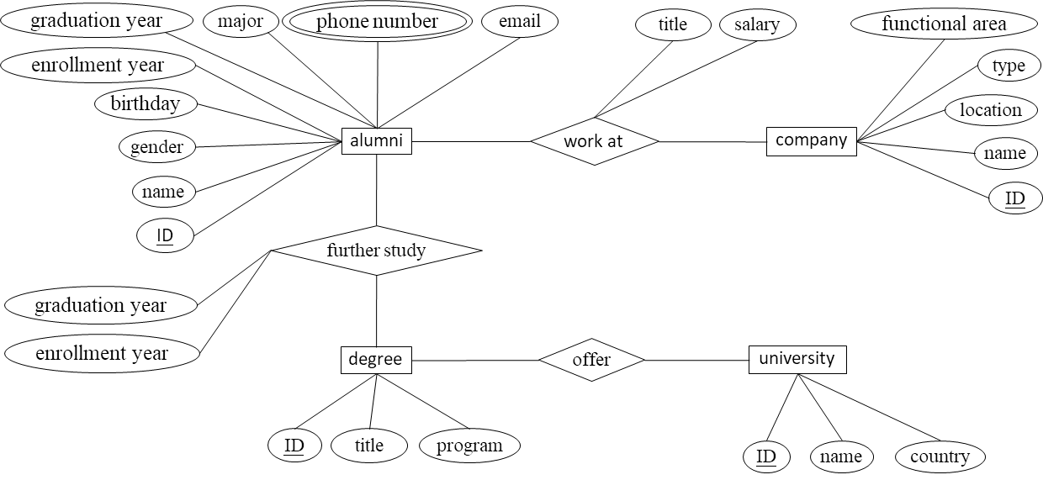
You do not need to make more assumptions on your design. Attributes can be omitted. It is possible to change some links or add more relationship sets.
Ans.
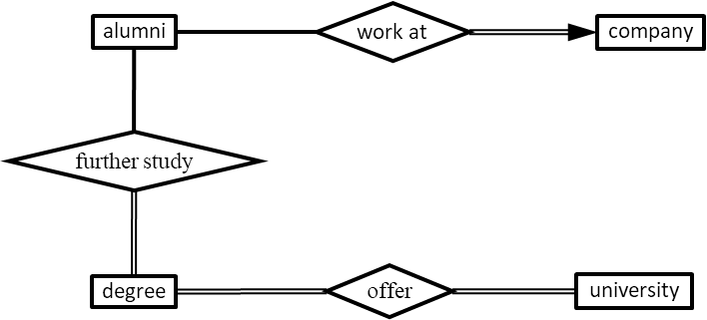

Q3. Given the following ER-model, justify which meaning can be expressed and which one cannot. You don’t need to give the reason. (16 marks)
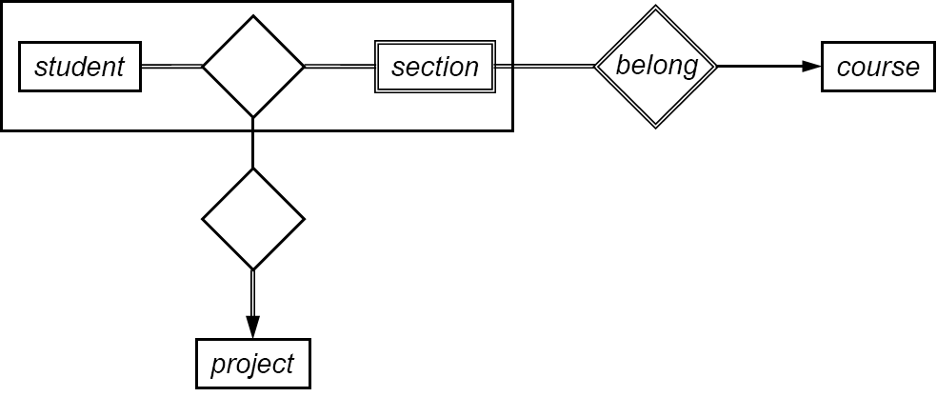
- Every project is a course project.
Ans. Yes.
“project” totally participates in the aggregation. So, every project is associated with a pair of student and section. “section” totally associated to “course”. Thus, every project is associated with a course.

- Every project is done by some students.
Ans. Yes.
Same as the above

- Some projects are group projects.
Ans. Yes.
The aggregation “student” – “section” is on the many side of the relationship set to “project”.

- Every student can only do one project for one course.
Ans. No.
The current model only has “project” on “one” side. So, one pair of student and section is only associated with one project. But, the cardinality constraint on “student” – “section” is many-to-many. So, one student can enroll multiple sections of one course.
Thus, one student can do multiple projects for one course.

- Every student can only enroll one section for one course.
Ans. No.
Same as the above

- Some courses do not have a project.
Ans. Yes.
The aggregation partially participates in the relationship set to “project”.

- If a section of a course has projects, then all other sections also have.
Ans. No.
“section” totally participates in the relationship set to “student”, but the constraint to project is partial.

- Students in the same group projects are from the same section.
Ans. No.

